# A PROJECT ON

**Dairy Product**

SUBMITTED IN

PARTIAL FULFILLMENT OF THE REQUIREMENT

FOR THE COURSE OF DIPLOMA IN MOBILE COMPUTING FROM CDAC



#### SUNBEAM INSTITUTE OF INFORMATION TECHNOLOGY

Hinjawadi

**SUBMITTED BY:**

**Adarsh Jagan Pal**

**UNDER THE GUIDENCE OF:**

**Mrs. Manjusha Nikam**

Faculty Member

Sunbeam Institute of Information Technology, Pune

ACKNOWLEDGEMENT

A project usually falls short of its expectation unless aided and guided by the right persons at the right time. We avail this opportunity to express our deep sense of gratitude towards Mr. Nitin Kudale (Center Coordinator, SIIT, Pune) and Mr. Yogesh Kolhe (Course Coordinator, SIIT ,Pune) .

We are deeply indebted and grateful to them for their guidance, encouragement and deep concern for our project. Without their critical evaluation and suggestions at every stage of the project, this project could never have reached its present form.

Last but not the least we thank the entire faculty and the staff members of Sunbeam Institute of Information Technology, Pune for their support.

**Adarsh Jagan Pal**

PG-DMC

SIIT Pune

# 1INTRODUCTION TO PROJECT

The Dairy Management System is a comprehensive web-based application designed to simplify and optimize the management of dairy products for businesses. This system enables administrators to easily manage product inventory, track orders, and ensure the seamless operation of their dairy business. Built using a modern technology stack, including Spring Boot for the backend and React for the frontend, the system offers a user-friendly interface for both administrators and customers.

Key features of the system include:

* Product Management: Administrators can add, update, and manage dairy products with ease, ensuring accurate inventory levels and product information.
* Order Processing: Customers can browse available dairy products, add them to their cart, and place orders, which are processed and tracked by the system.
* User Management: The system supports user authentication and authorization, with separate interfaces for administrators and customers.
* Real-Time Inventory Updates: The system automatically updates product quantities as orders are placed, ensuring that customers always see the most up-to-date information.
* Responsive Design: The application is accessible on various devices, providing a seamless experience whether accessed on a desktop, tablet, or mobile device.

This project showcases a robust and scalable solution for managing dairy products, aimed at improving operational efficiency and customer satisfaction.

**2.REQUIREMENTS**

**2.1 FUNCTIONAL REQUIREMENTS**

Customer

### **2.1 User Account**

The user, henceforth referred to as the ‘customer’, will be presented with two choices by the Dairy Management system as the first step in the interaction. These choices depend on whether the customer is a registered customer or a new customer.

* Registered Customer: A customer who has previously purchased dairy products and has been given a user ID and password. This personal information will be referred to as their ‘profile’. A customer with a profile in the DB-user will be called a ‘registered customer’. A registered customer can view available dairy products, and place an order by logging into the system.
* New Customer: A new customer must register themselves by providing personal information to create a profile. Once registered, they become a registered customer and can then view available dairy products and place an order.

Since registering is mandatory for new customers, there is no guest login option. The term ‘availability of dairy products’ refers to viewing the product list, prices,quantity. The system shall provide the customer with an option to exit at any time during the processes described.

### **2.2 Registration and Creation of Customer Profile**

The system shall require a customer to register in order to carry out any transactions, including viewing and purchasing dairy products. During registration, the system will prompt the customer for the following mandatory information:

* User name
* Email
* Mobile Number
* Password
* Confirm Password



### 2.3 Home Page

The home page is the central interface of the Dairy Management system, providing users with easy access to all key features and information. It is designed to be user-friendly and intuitive, ensuring that both new and returning customers can navigate the system with ease. The following sections detail the main components and functionality of the home page:

#### 2.3.1 Navigation Bar

The navigation bar is located at the top of the home page and provides quick links to the following sections:

* Home: Returns the customer to the home page from any part of the system.
* About Us: Provides information about the Dairy Management system, the company’s values, and mission.
* Login: Allows existing customers to log into their accounts.
* Register: Provides an option for new customers to create an account by registering with the system.
* Contact Us: Offers details on how to reach customer support for inquiries or assistance.

### 2.3.2 User-Specific Content

On the home page, once a customer is logged in, they will have access to user-specific content and functionalities tailored to their needs. This includes a dropdown menu for easy navigation to various profile and account-related sections. The following elements are included:

#### 2.3.2.1 Dropdown Menu

The dropdown menu is accessible from the navigation bar or a user profile icon and includes the following options:

* Update Profile: Allows customers to view and edit their personal information, such as address, phone number, and payment method. This section ensures that customer details are kept up to date.
* Cart: Provides a link to view and manage the items currently in the customer’s cart. Customers can adjust quantities, remove items, and proceed to checkout from this section.
* Orders: Allows customers to access their order history and track current orders. Customers can view past purchases, check the status of ongoing orders, and find details about each transaction.
* Logout: Provides a secure way for customers to log out of the system. This option ensures that the customer’s session is terminated and that their account remains protected.

#### 2.3.2.2 Additional User-Specific Features

* Order Alerts: Notifies customers about the status of recent orders, such as added to cart or order success.

#### 2.3.2.3 Visibility and Access

* Navigation Bar: The dropdown menu and user-specific content are accessible from the navigation bar, ensuring that registered customers can easily find and manage their account details.
* Home, About Us, Contact Us, and Products: These links remain accessible at all times from the navigation bar, providing quick access to general information about the system, contact options, and the product catalog.

This structure ensures that registered customers have a personalized and efficient experience on the home page, with easy access to important account management features and user-specific content.

### **2.4 User Profile Management**

Once registered, a customer will have access to a personal user profile within the Dairy Management system. This profile serves as the central hub for managing their account details, shopping cart, orders, and logout options. The following sections explain these functionalities in detail:

#### 2.4.1 Profile Overview

Upon logging into the system, the customer can access their profile, which will display their personal information (e.g., name, address, contact details). Customers can update their personal information, such as address, phone number, or preferred payment method, from this profile section.

#### 2.4.2 Cart Management

The customer’s cart is a temporary holding area for dairy products they are interested in purchasing. The cart management functionality includes:

* Adding Products to Cart: Customers can browse the available dairy products and add them to their cart. Each product added to the cart will be displayed with its quantity, price, and any applicable discounts.
* Updating Cart: Customers can modify the contents of their cart by:
  + Changing Quantity: Adjusting the quantity of each product in the cart.
  + Removing Products: Removing specific products from the cart.
* Viewing Cart: Customers can view a summary of the products in their cart, including the total cost, before proceeding to checkout.
* Saving Cart: Customers can save their cart for future reference. This allows them to continue shopping later without losing their selected items.

#### 2.4.3 Order Management

After finalizing the contents of their cart, customers can proceed to place an order. The order management functionality includes:

* Placing an Order: Once a customer confirms their cart, they can proceed to the checkout process, where they review their order details and confirm payment. Upon successful payment, the order is placed.
* Order History: The customer’s profile will maintain a history of all past orders, including order details such as products purchased, total cost.
* Canceling Orders: If an order has not yet been processed or shipped, customers have the option to cancel the order directly from their profile.

#### 2.3.4 Logout

The logout functionality ensures that customers can securely exit the Dairy Management system when they are done using it. Key aspects of the logout process include:

* Session Termination: Logging out will terminate the customer’s session, preventing unauthorized access to their profile and cart.
* Redirect: After logging out, customers will be redirected to the login page of the Dairy Management system.
* Security: The system will automatically log out customers after closing the browser to protect their accounts from unauthorized access.

These functionalities together ensure that customers have full control over their profiles, shopping experience, and security while using the Dairy Management system.

Administrator

Admin should be able to login ,add products , update product information,Delete products and see user Information according to user Id.

* 1. **NON FUNCTIONAL REQUIREMENTS**

#### **2.2.1 Performance**

* Response Time: The system should respond to user actions, such as browsing products, adding items to the cart, and processing orders, within 2 seconds to ensure a smooth user experience.
* Scalability: The system must be able to handle an increasing number of users and transactions without significant performance degradation. It should be scalable to accommodate growth in the number of products and customer base.

#### 2.2.2 Usability

* User Interface: The system should have an intuitive and user-friendly interface, ensuring that customers can easily navigate through the product catalog, manage their cart, and complete transactions with minimal effort.
* Accessibility: The system should be accessible to users with disabilities, adhering to standards such as the Web Content Accessibility Guidelines (WCAG) to ensure all users can interact with the system effectively.

#### 2.2.3 Reliability

* Availability: The system should have an uptime of 99.9% to ensure continuous availability for customers. Maintenance windows should be scheduled during off-peak hours to minimize disruption.
* Error Handling: The system should gracefully handle errors and exceptions, providing clear and helpful error messages to users and ensuring that order is added or not ordered .

#### 2.2.4 Security

* Data Protection: Customer data, including personal must be protected.
* Authentication and Authorization: The system should implement secure authentication methods and ensure that users can only access resources and perform actions for which they are authorized.

#### 2.2.5 Maintainability

* Code Quality: The system’s codebase should be well-organized, documented, and follow best practices to facilitate ease of maintenance and future development.
* Modularity: The system should be designed with modular components to allow for easier updates, bug fixes, and integration of new features without impacting the overall system.

#### 2.2.6 Compatibility

* Browser Compatibility: The system should be compatible with all major web browsers (e.g., Chrome, Firefox, Safari, Edge) and should function correctly on different devices (e.g., desktops, tablets, smartphones).
* Integration: The system should be capable of integrating with third-party services such as payment gateways, email providers, and shipping carriers to support a complete e-commerce workflow.

These non-functional requirements are essential for ensuring that the Dairy Management system provides a reliable, secure, and user-friendly experience while supporting its intended growth and functionality.

**3. DESIGN**

**3.1 Database Design**

The following table structures depict the database design.

# Table1: Users

|  |  |  |  |  |  |
| --- | --- | --- | --- | --- | --- |
| **Field** | **Type** | **Null** | **Key** | **Default** | **Extra** |
| userid | int | NO | PRI | NULL | auto_increment |
| email | varchar(255) | YES |  | NULL |  |
| mobile | varchar(255) | YES |  | NULL |  |
| uname | varchar(255) | YES |  | NULL |  |
| password | varchar(255) | YES |  | NULL |  |

## **Table2: Orders**

|  |  |  |  |  |  |
| --- | --- | --- | --- | --- | --- |
| **Field** | **Type** | **Null** | **Key** | **Default** | **Extra** |
| oid | int | No | PRI | NULL | auto_increment |
| uid | int | Yes | MUL | NULL |  |
| pid | int | Yes | MUL | NULL |  |
| quantity | int | Yes |  | NULL |  |

# Table3:Product

|  |  |  |  |  |  |
| --- | --- | --- | --- | --- | --- |
| **Field** | **Type** | **Null** | **Key** | **Default** | **Extra** |
| pid | int | No | PRI | NULL | auto_increment |
| productName | varchar(255) | YES |  | NULL |  |
| pimage | varchar(255) | YES |  | NULL |  |
| price | double | No |  | NULL |  |
| category | varchar(255) | YES |  | NULL |  |
| quantity | int | No |  | NULL |  |
| description | varchar(255) | YES |  | NULL |  |

### Table4: admin

|  |  |  |  |  |  |
| --- | --- | --- | --- | --- | --- |
| **Field** | **Type** | **Null** | **Key** | **Default** | **Extra** |
| adminid | int | No | PRI | NULL | auto_increment |
| email | varchar(255) | YES |  | NULL |  |
| password | varchar(255) | YES |  | NULL |  |
| phone | varchar(255) | YES |  | NULL |  |

**E-R Diagram,Dataflow diagram and Class Diagram:**

Go to Appendix A

**4. CODING STANDARDS IMPLEMENTED**

### Naming and Capitalization

Below summarizes the naming recommendations for identifiers in Pascal casing is used mainly (i.e. capitalize first letter of each word) with camel casing (capitalize each word except for the first one) being used in certain circumstances.

|  |  |  |  |
| --- | --- | --- | --- |
| **Identifier** | **Case** | **Examples** | **Additional Notes** |
| Class | Pascal | Person, BankVault, SMSMessage, Dept | Class names should be based on "objects" or "real things" and should generally be **nouns**. No ‘_’ signs allowed. Do not use type prefixes like ‘C’ for class. |
| Method | Camel | getDetails, updateStore | Methods should use **verbs** or verb phrases. |
| Parameter | Camel | personName, bankCode | Use descriptive parameter names. Parameter names should be descriptive enough that the name of the parameter and its type can be used to determine its meaning in most scenarios. |
| Interface | Pascal with "I" prefix | Disposable | Do not use the ‘_’ sign |
| Property | Pascal | ForeColor, BackColor | Use a noun or noun phrase to name properties. |
| Associated private member variable | _camelCase | _foreColor, _backColor | Use underscore camel casing for the private member variables |
| Exception Class | Pascal with "Exception" suffix | WebException, |  |

### Comments

* Comment each type, each non-public type member, and each region declaration.
* Use end-line comments only on variable declaration lines. End-line comments are comments that follow code on a single line.
* Separate comments from comment delimiters (apostrophe) or // with one space.
* Begin the comment text with an uppercase letter.
* End the comment with a period.
* Explain the code; do not repeat it.

**5. TEST REPORT**

**Another group called Linux did the testing and the report of the testing is given hereunder.**

**GENERAL TESTING:**

|  |  |  |  |  |
| --- | --- | --- | --- | --- |
| **SR-NO** | **TEST CASE** | **EXPECTED RESULT** | **ACTUAL RESULT** | **ERROR MESSAGE** |
| 1 | Register Page | Register successful | OK | If password and confirm password are not same then give toast message invalid credentials |
| 2 | Login Page | Login successful | Ok | Please enter username and password again . |
| 3 | Profile details and logout  Fragment | Profile details show successful and after logout application closed. | Ok | Nothing |
| 4 | ProductListFrament | Products show on screen | ok | nothing |
| 5 | ProductDetails | Product details show succssfully | ok | nothing |
| 6 | OrderFragment | After buy product show in orders | ok | nothing |

**6. PROJECT MANAGEMENT RELATED STATISTICS**

|  |  |  |  |
| --- | --- | --- | --- |
| **DATE** | **WORK PERFORMED** | ****SLC Phase**** | **Additional Notes** |
| MAY 1,2024 | Project Allotment and User Requirements Gathering | Feasibility Study | We Check Websites and know about Product requirements of User. |
| MAY 4,2024 | Initial Dairy Product Document Validation  And Team Structure Decided | Requirement Analysis | The initial Dairy Product was presented to the client to understand his requirements better |
| MAY 14,2024 | Designing the use-cases, Class Diagram, Collaboration Diagram, E-R Diagram and User Interfaces | Requirement Analysis &  Design Phase | Database Design completed |
| MAY 18,2024 | Business Logic Component design Started | Design Phase | ---------------------- |
| MAY 28,2024 | Coding Phase Started | Coding Phase | 70% of Class Library implemented. |
| JUNE 12,2024 | Implementation of Web Application and Window Application Started | Coding Phase | Class Library Development going on. |
| JUNE 21, 2024 | Off | Off | Off |
| JUNE 29, 2024 | Implementation of Web Application and Window Application Continued | Coding Phase and Unit Testing | Class Library Modified as per the need. |
| JULY 13, 2024 | Implementation of Web Application and Window Application Continued | Coding Phase and Unit Testing | -- |
| JULY 25, 2024 | After Ensuring Proper Functioning the Required Validations were Implemented | Coding Phase and Unit Testing | Module Integration was done by the Project Manager |
| AUG 5, 2024 | The Project was Tested by the respective Team Leaders and the Project Manager | Testing Phase (Module Testing) | -- |
| AUG 10, 2024 | The Project was Submitted to Other Project Leader of Other Project Group For Testing | Testing Phase (Acceptance Testing) | The Project of Other Team was Taken up by the Team for Testing |
| AUG 14, 2024 | The Errors Found were Removed | Debugging | The Project was complete for submission |
| AUG 16,2024 | Final Submission of Project |  |  |

Appendix A

Entity Relationship Diagram

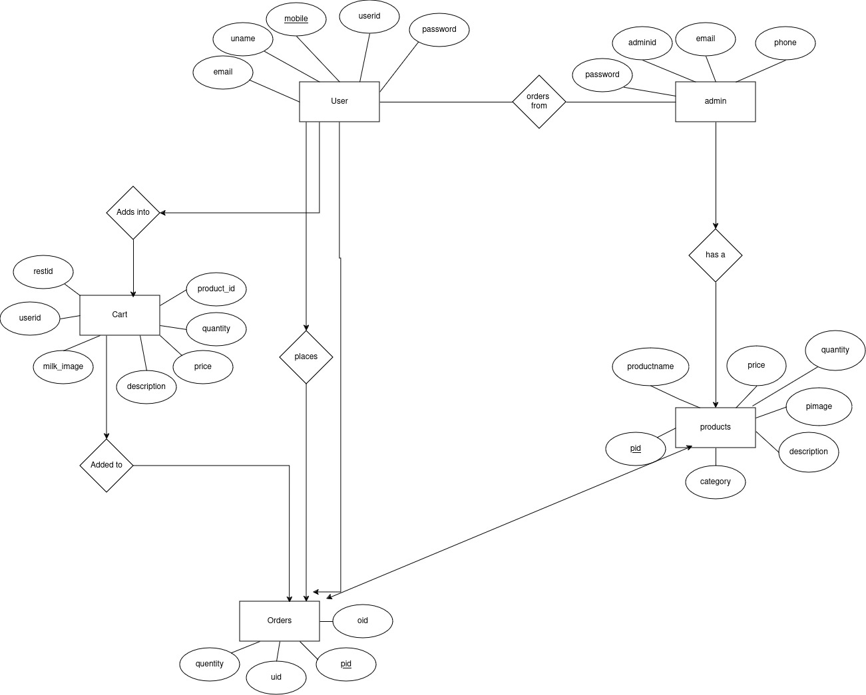

**Data Flow Diagram:**

External System

Dairy Management System

Appendix B

Homepage:

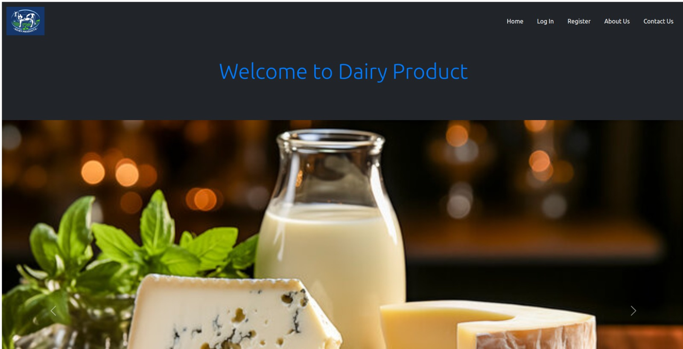

LoginPage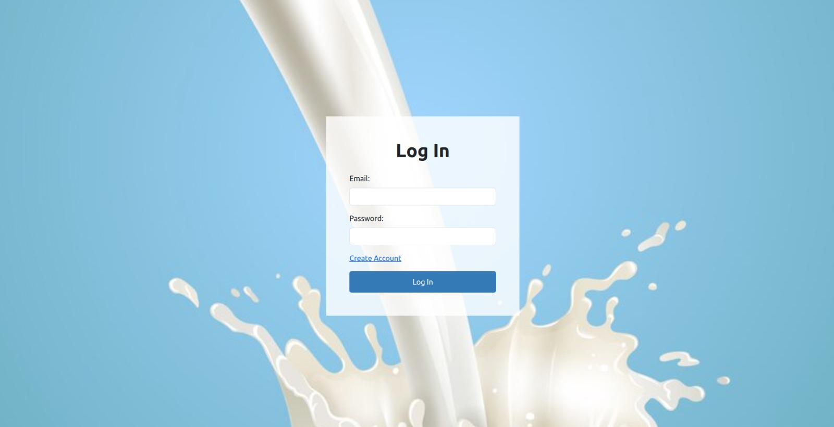:

User Registration:

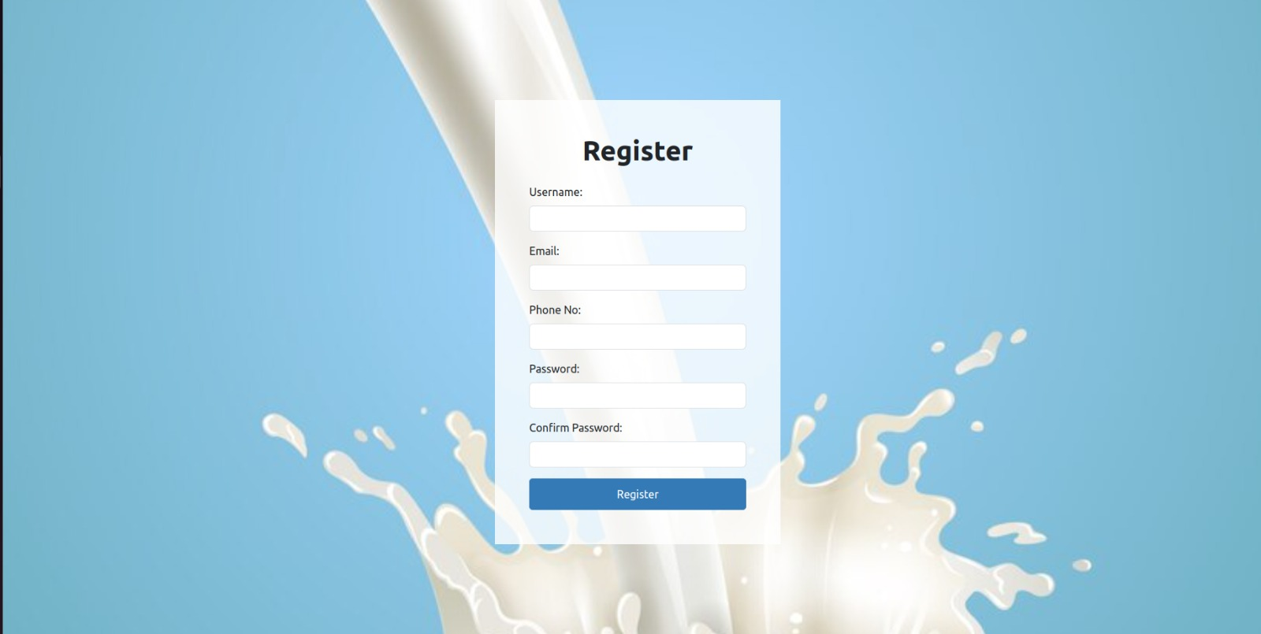

About Us:

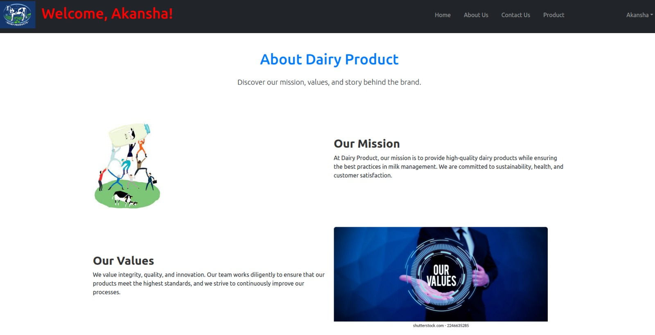

**Contact Us:**

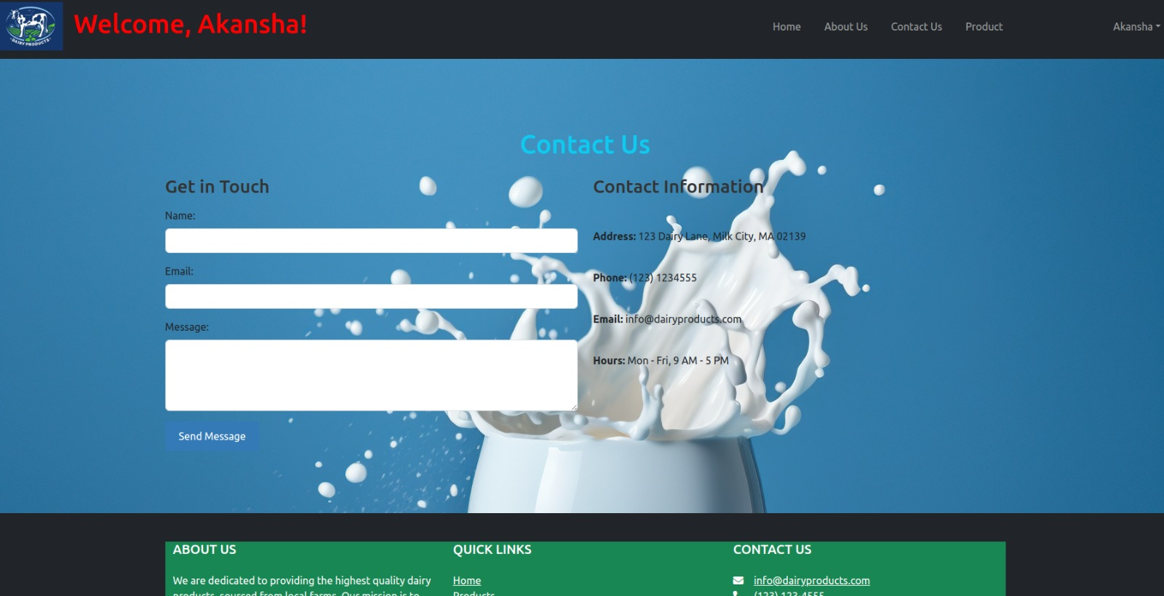

**Update User:**

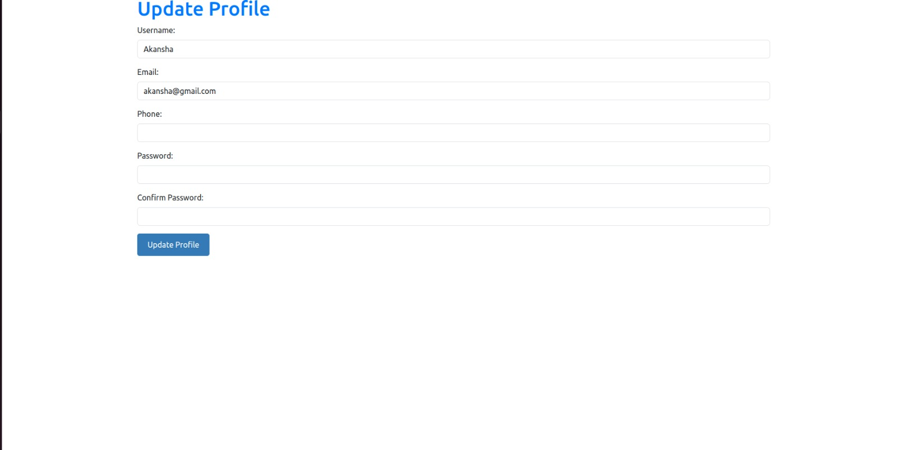

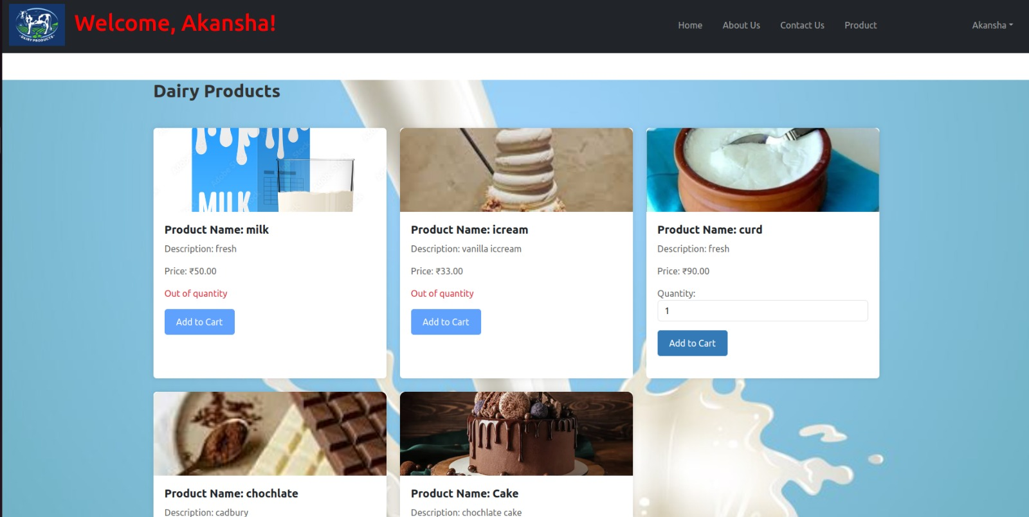

**Products:**

**Cart:**

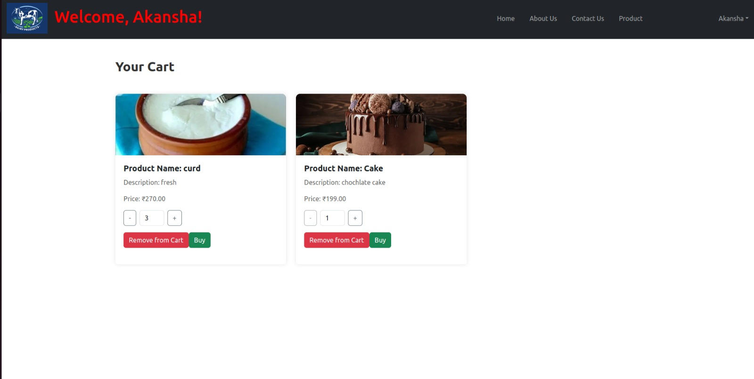

**Order:**

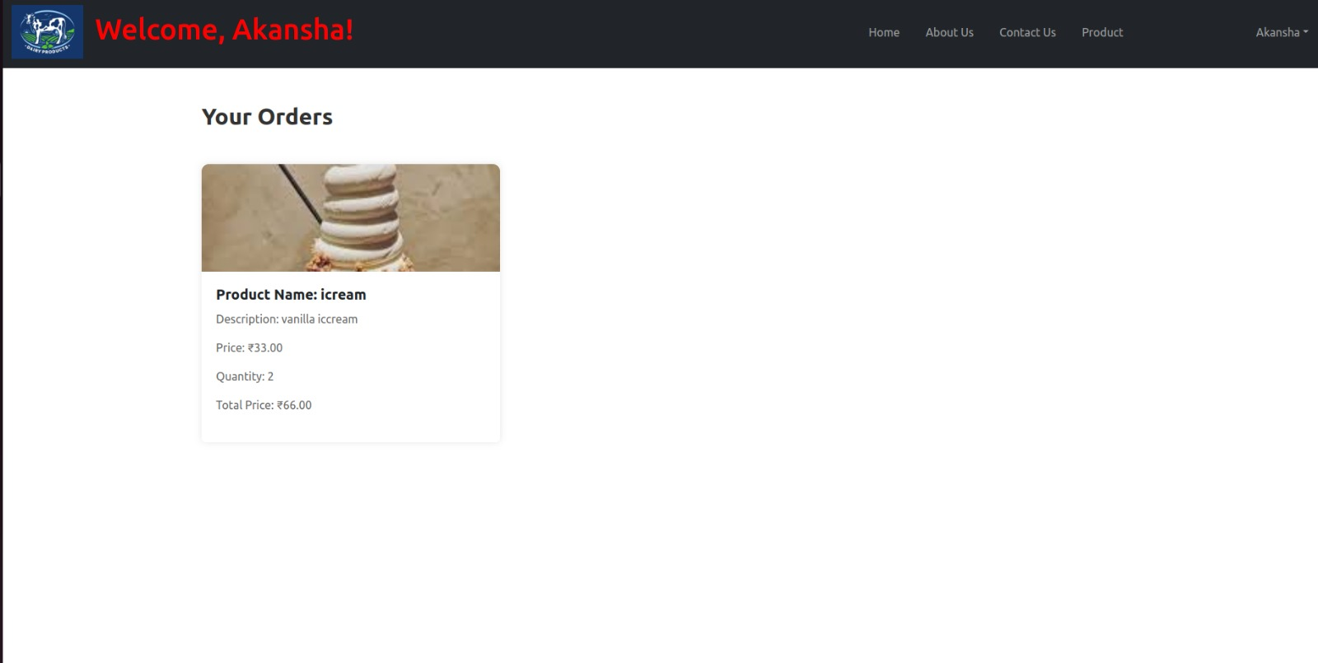

**Admin Dashboard:**

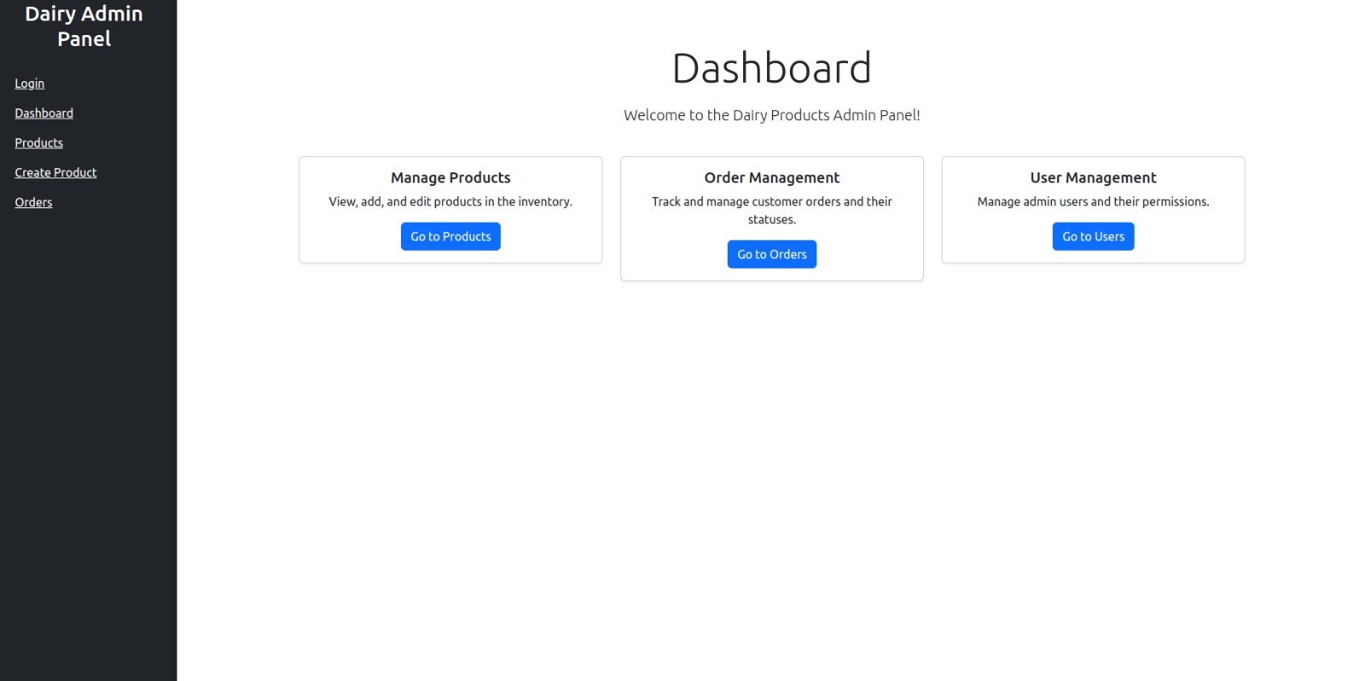

**Admin Login:**

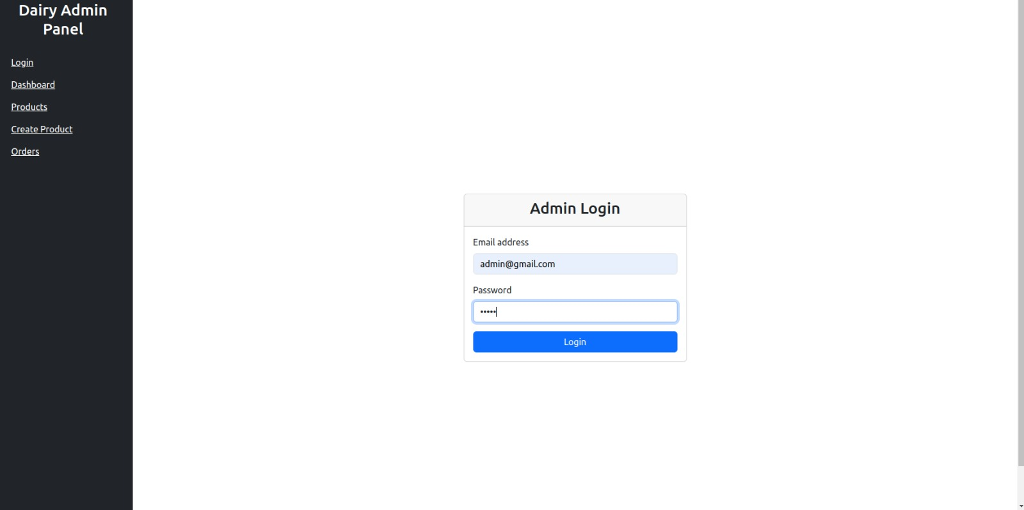

**Product Manage:**

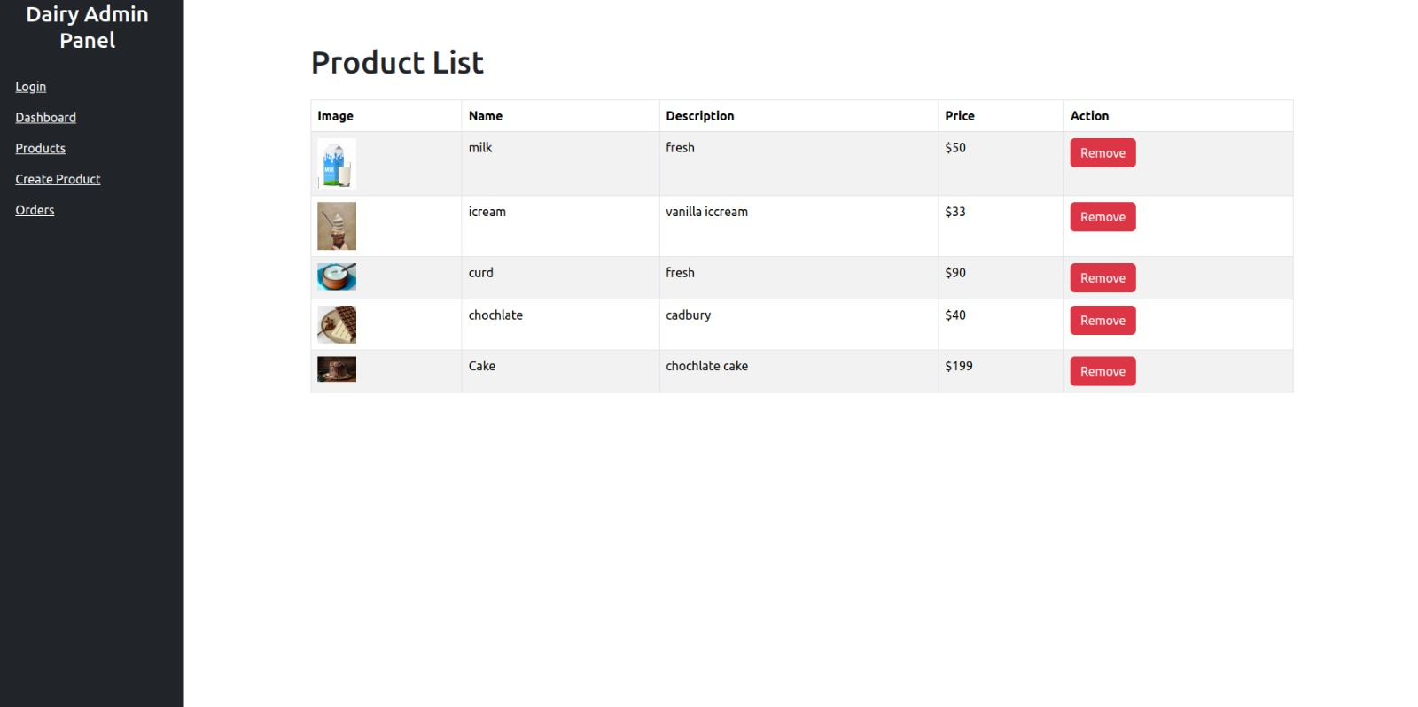

**Add Product:**

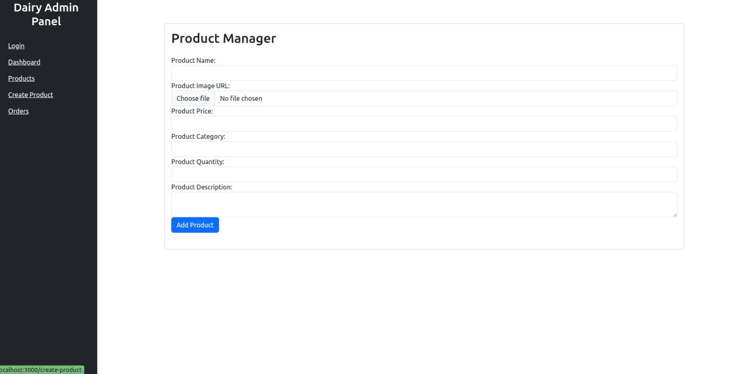

**Order Management:**

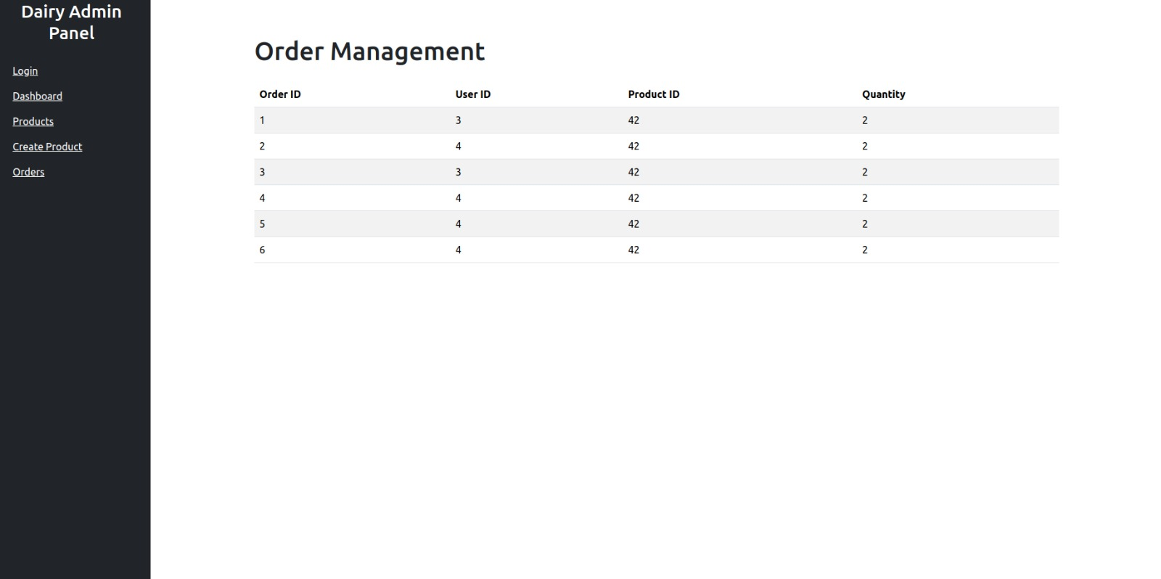

**Mobile Application Register:**

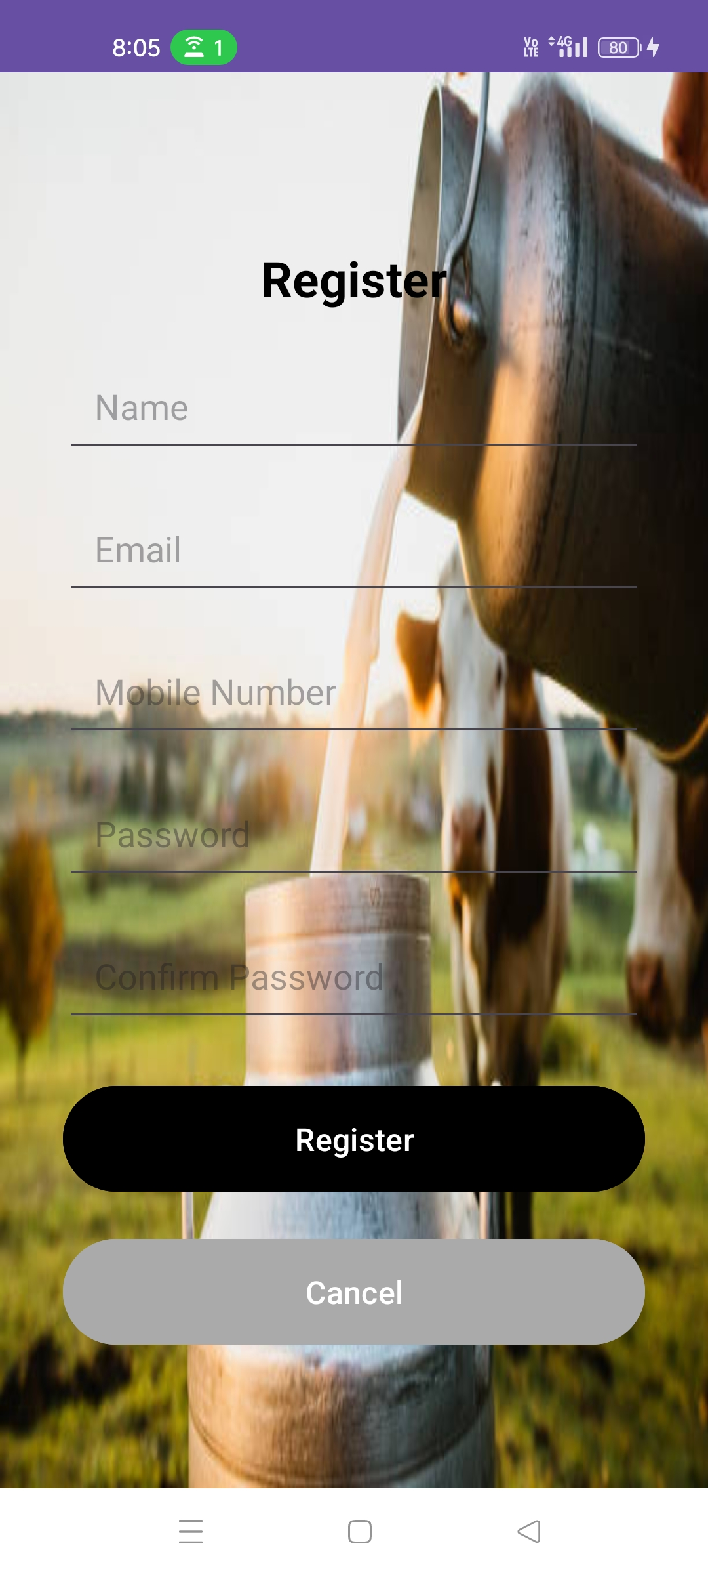

**Mobile Application Login:**

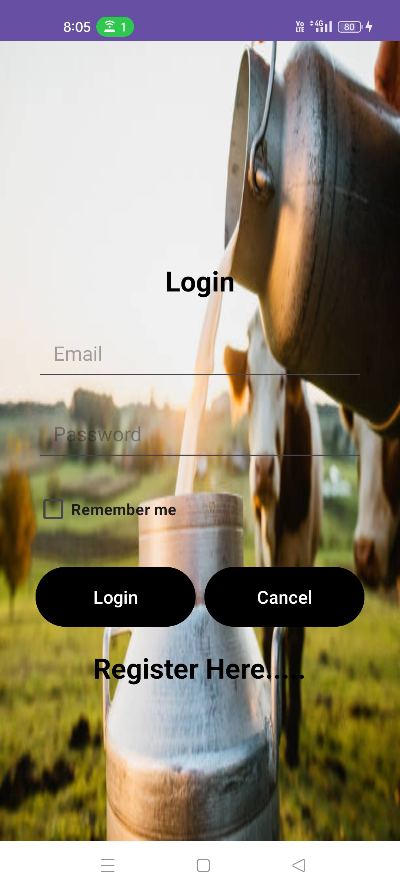

**Mobile Application Fragments:**

**a) products**

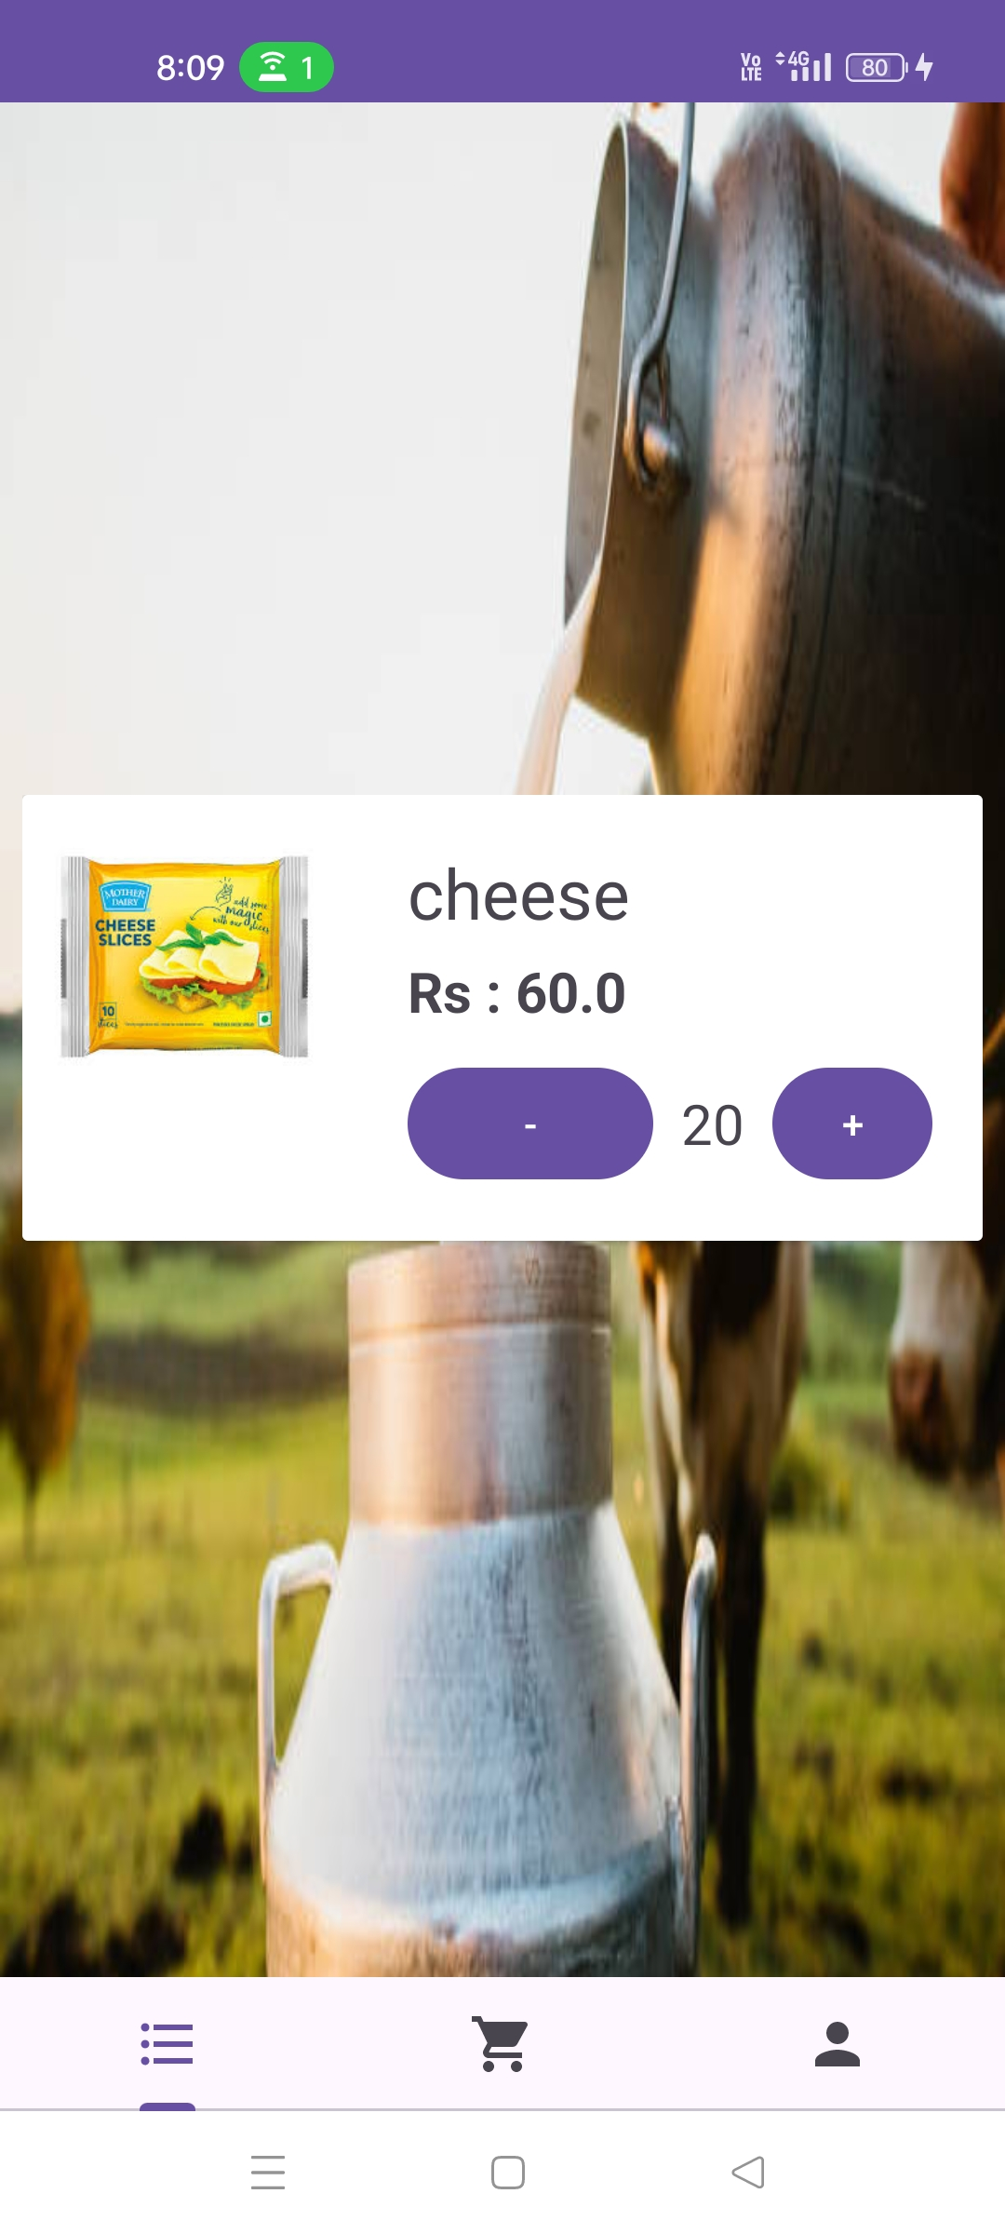

**b) orders**

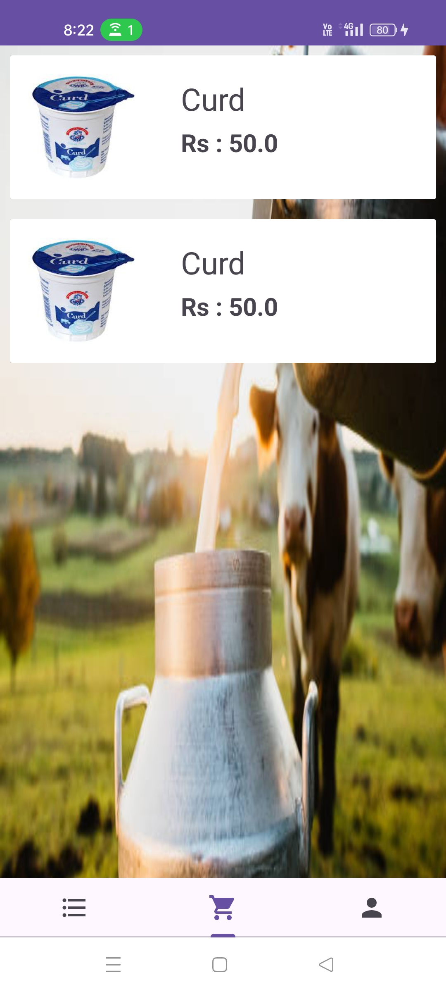

**c) profile and logout**

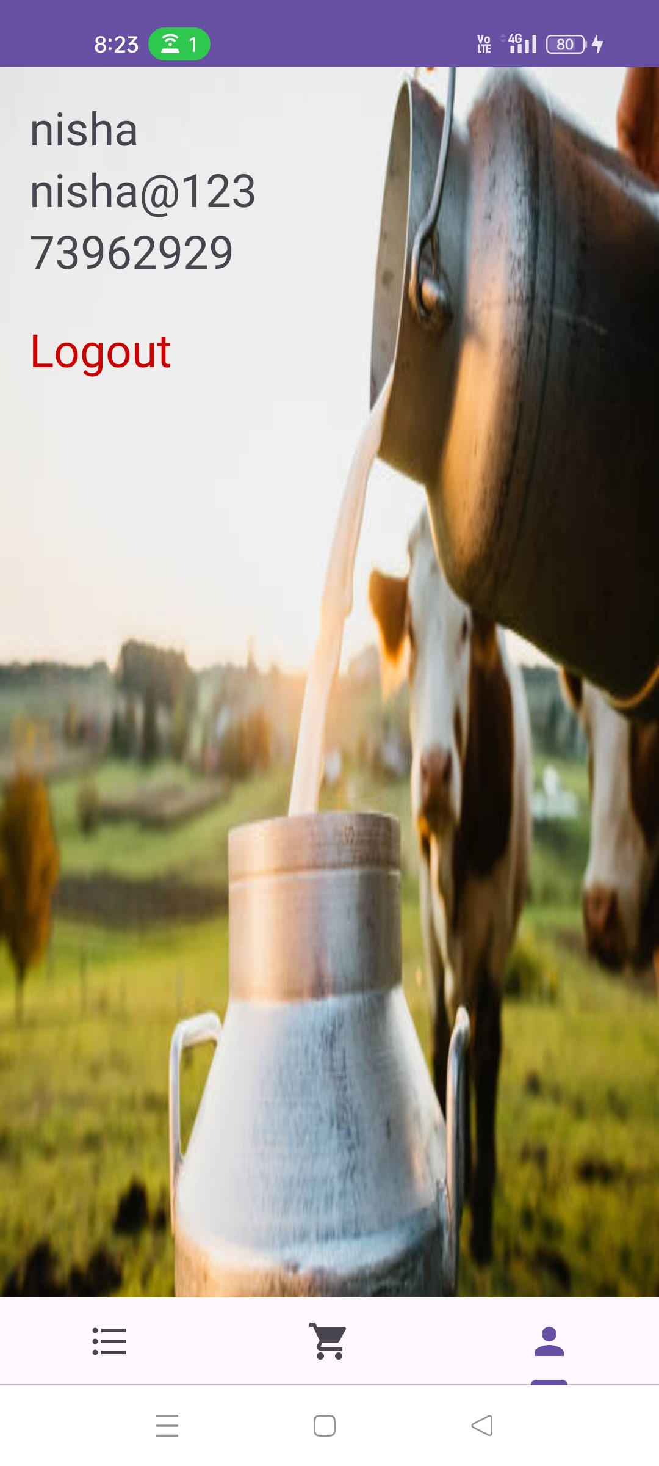

**Mobile Application profile details:**

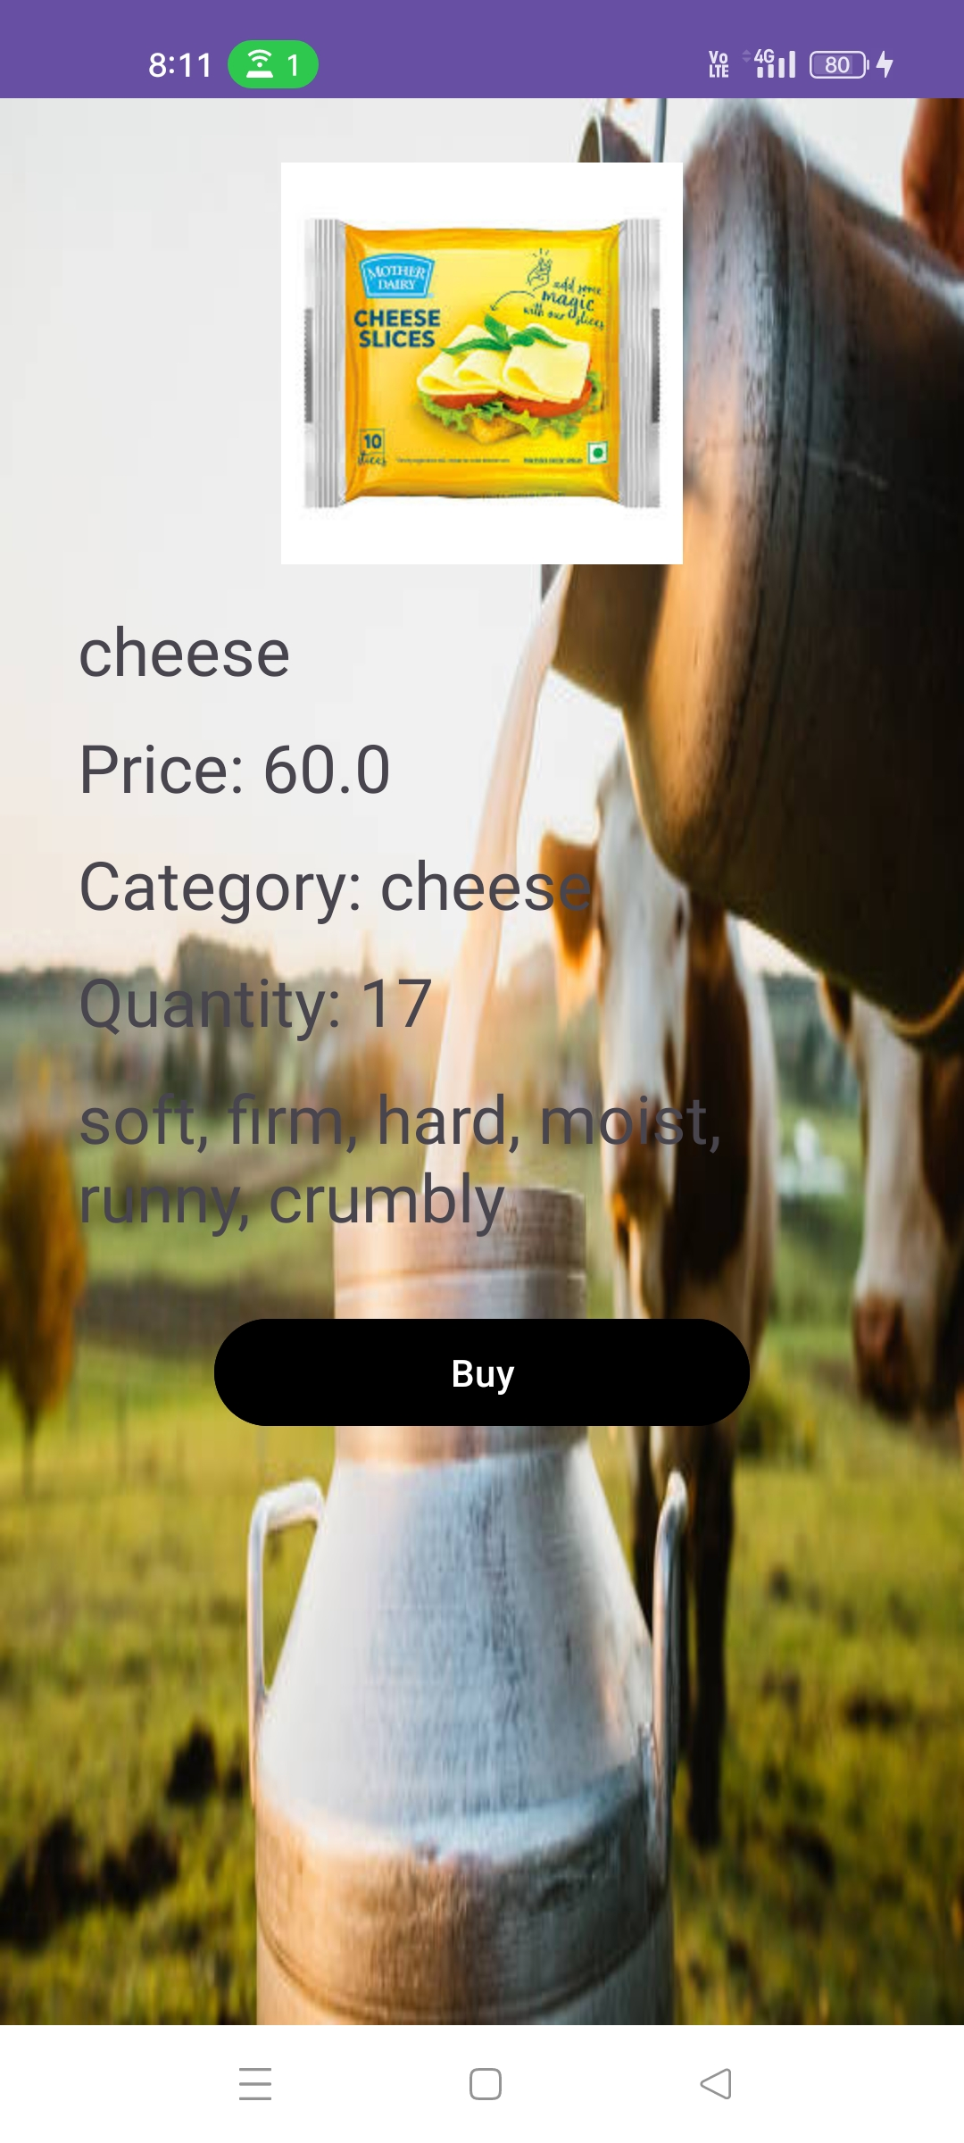

**7.REFERENCES:**

[http://www.google.com](http://www.google.com/)

[http://](http://www.xml101.com:8081/xml/)desifarmsindia.in

App ref:

countrydelightmobileapp

http://www.w3.org

http://www.wikipedia.org

# A PROJECT ON

**“ DAIRY PRODUCTS”**

SUBMITTED IN

PARTIAL FULFILLMENT OF THE REQUIREMENT

FOR THE COURSE OF

DIPLOMA IN MOBILE COMPUTING FROM CDAC



#### SUNBEAM INSTITUTE OF INFORMATION TECHNOLOGY

Hinjawadi

**SUBMITTED BY:**

Adarsh Jagan Pal

**UNDER THE GUIDENCE OF:**

Mrs. Manjusha Nikam

Faculty Member

Sunbeam Institute of Information Technology, PUNE.



**CERTIFICATE**

This is to certify that the project work under the title ‘Dairy Products’ is done by Nisha Dipak Kadam in partial fulfillment of the requirement for award of Diploma in Mobile Computing Course.

**Mrs. Manjusha Nikam Mr.Yogesh Kolhe**

**Project Guide Course Co-Coordinator**

Date:16-08-2024